**Password Change**

If you get the below error: your password has expired

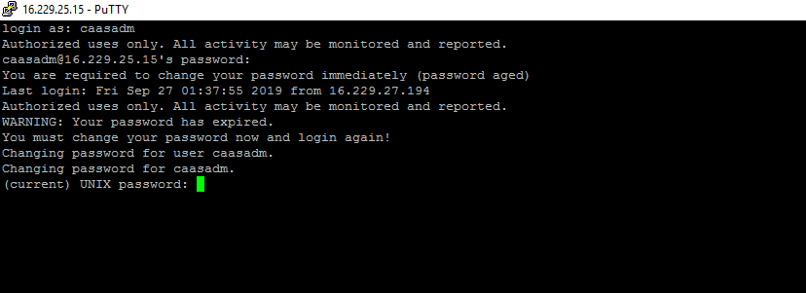

1. Change password to some temporary password like: Qwertyuiop!2017
2. Then again login to the same node using the new password(Qwertyuiop!2017)
3. Login as root user using sudo –s
4. Then change the password for the required user(ansible/caasadm)

